CERTIFICATE OF DELIVERY

DATE | 08/01/2026
EQUIPMENT | Sweep Tester

PHOTO | ITEM | CANT
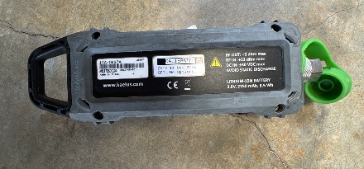 | IVA-0627A  Kaelus  AN1172500104 | 1
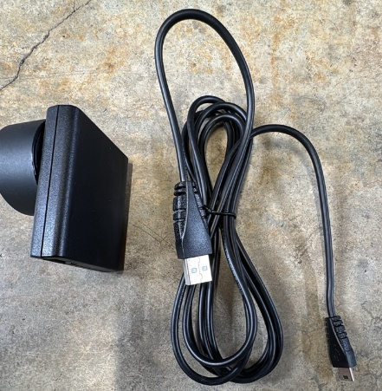 | AC Power adapter | 1
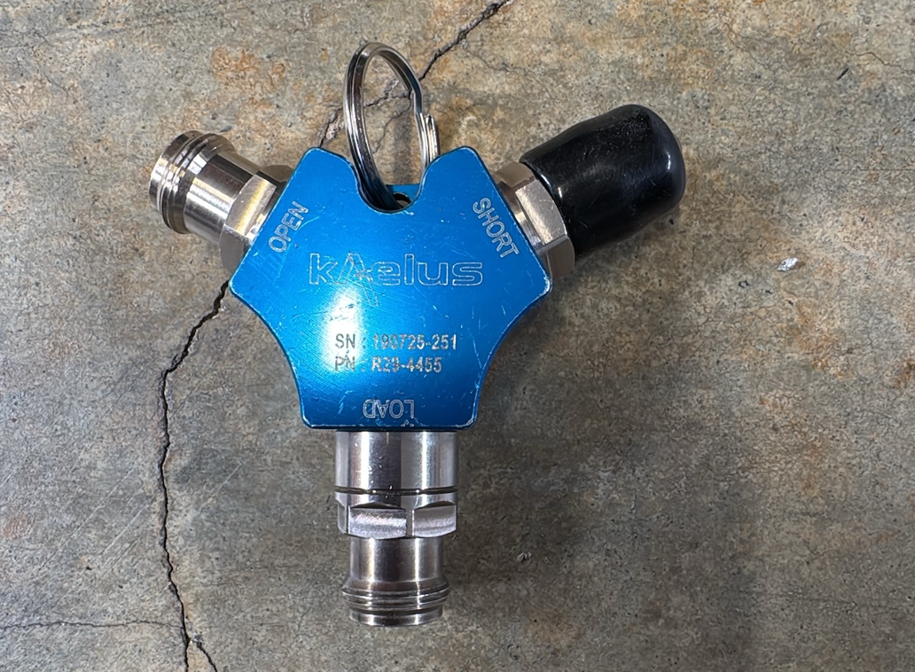 | Open short load calibrator  190725-251 | 1
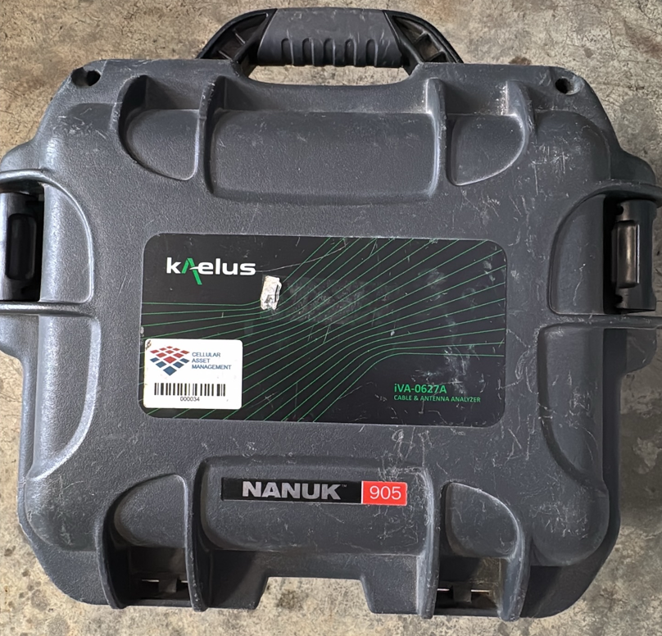 | Black box | 1
\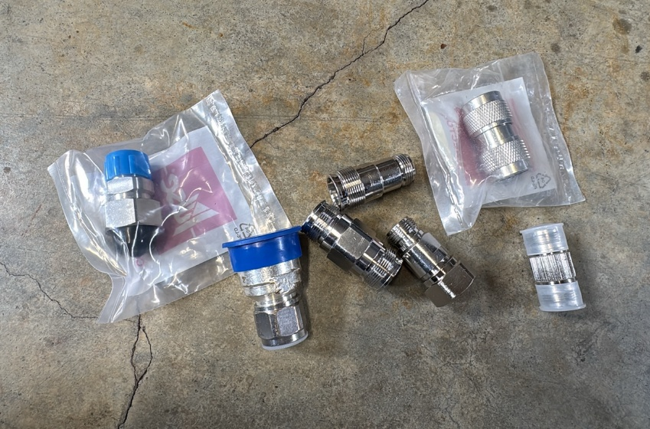 | Adaptors
 | 4.3-10-M to N-F | 1
 | N-M to 4.3-10-F | 1
 | 4.3-10-F to 4.3-10-F | 1
 | N-F to 4.3-10-F | 1
 | 4.3-10-F to 4.3-10-M | 1
 | N-M to N-M | 1
 | N-F to N-F | 1

COMMENT:

